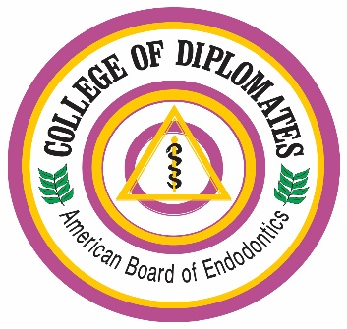

College of Diplomates
Summer Conference 2018
Schedule of Events
(The COD is an ADA CERP-Recognized Provider)

Thursday, August 2

1-5 p.m. The College of Diplomates is offering mock ABE Oral Board examinations (9 slots) and Case Portfolio review (6 slots) for ABE candidates that register for the College of Diplomates Summer Conference. Spaces are limited.

Mock ABE Oral Boards
- (2) 30 minute oral exams with 2 examiners + 10 minutes of feedback
- Limit 9 candidates

ABE Case History Portfolio Review / Feedback
- 30 minutes sessions per candidate with 1 examiner; feedback on 2 cases
- Limit 6 candidates

6 - 9 p.m. Welcome Reception- outdoor patio

Friday, August 3

7 -9 a.m. Breakfast

8 – 9:30 a.m. The Opioid Crisis- How Did We Get Here and What Do We Do Now? Implications for Dental Practice.
DEA Agent

9:30 – 10 a.m. Break

10-12 p.m. Street Drugs Exposed: What Your Kids and Your Patients Don’t Tell You
Dr. Harold L. Crossley, DDS, MS, PhD

12:30 – 1:30 Challenging Patients/Challenging Conversations
Dr. Leesa Morrow, PhD, JD, LP

6 - 9 pm Mixologist/Historian Cocktail hour, followed by Dinner

Saturday, August 4

7 - 9 a.m. Breakfast Buffet

8 – 9:30 a.m. Managing Pain in the Era of the Opioid Crisis Dr. Harold L. Crossley, DDS, MS, PhD

9:30 – 9:45 a.m. Break

9:45 - 11:15 a.m. Non-Pharmacologic Management of Pain Patient
Dr. Leesa Morrow, PhD, JD, LP

11:15 – 11:30 a.m. Break

12 - 1:30 p.m. Move to Health, Changing the Conversation
Dr. Hope Williamson-Younce, PhD, NP, RN
Dr. Colleen Shull, DMD, MS

7:05pm Group outing- Nationals Game

