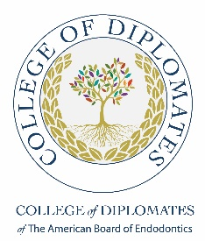
NiCollege of Diplomates
Summer Conference Agenda
August 11-14, 2022

Day 1, Thursday, August 11, 2022
6pm - 7:30pm Registration/Welcome Cocktail Hour
Outdoor Venue (Ballroom Terrace)
Menu to include heavy appetizers as well as signature drinks. Activities include a magician and/or balloon artist and face painting for our younger guests

Day 2, Friday, August 12th
8am - 8:30am Continental Breakfast & Introductions
8:30am– 10:00am Dr. Niemcyzk (1.5 CE)

10:15am-12:15 pm Dr. Niemcyzk (2.0 CE)

12:15pm- 1:00pm Lunch
1:00pm- 3:00pm Dr. Anil Kishen- topic (2.0 CE)
Current Concepts in Disinfection

3:15-pm- 5:15 pm Dr Anil Kishen- continued (2.0 CE)
Nanotechnology: Impact on Disinfection

6:30pm- 9pm Cocktails & Silver Jubilee Celebration Dinner
Outdoor venue (Alpine Club)

Saturday, August 13th
8:00am– 10:00am Dr. Craig Schneider (2.0 CE)
Periradicular and Peri-implant Extended Lesions and their role in persistent symptoms and treatment failures (2D and 3D)

10:15pm- 12:15pm Dr. Bruno Azevedo (1.5 CE)
CBCT New Dimensions

Sunday, August 15th
8am – 9am Closing Remarks and Farewell Breakfast
9am- 11am Dr. Bruno Azevedo
Hands on CBCT (limited space)

