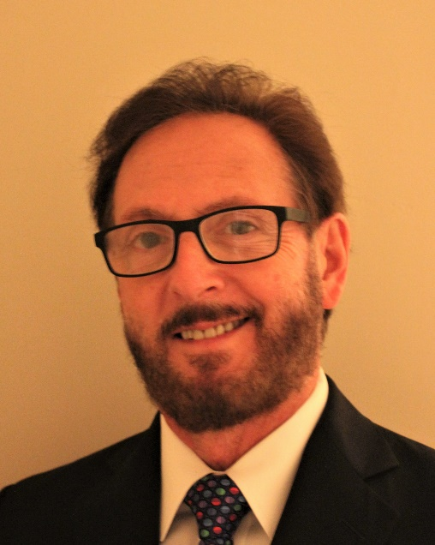

PERIRADICULAR and Peri-implant EXTENDED LESIONS (IN 2D AND 3D)
S. Craig Schneider, DDS, MAGD, LLSR
Private practice limited to endodontics and microsurgery Dean’s Faculty, Clinical Assistant Professor, Division of Endodontics, University of Maryland School of Dentistry
Disclosures: Nothing to disclose

This presentation uses 2D and 3D microscopy to demonstrate the presence of periradicular and peri-implant extended lesions in cases with idiopathic orofacial pain and/or failure to heal after appropriate endodontic treatment, extractions, placement of osseous grafts or implants. Current microscopy with both higher resolution and magnification reveals different types and locations of extraosseous and extended lesions outside the alveolar bone that cannot be seen with radiography. Multiple cases with long-term follow-up will be presented in 2D to show how one or more teeth were resolved only when microsurgery removed both the periradicular lesions and their extended portions. More advanced cases will be presented in 3D to best demonstrate extraosseous, intramucosal and extraneural extensions, and complex lesions involving multiple dentoalveolar sites and adjacent anatomical structures. Similar cases involving implants will also be shown. The use of focused-field CBCT in treatment planning will be discussed. Dental and medical implications will also be presented and related to the types and locations of the extensions. These cases will demonstrate how accurate diagnosis and treatment consistently result in (1) complete resolution of the infection and its associated symptoms, and (2) the long-term retention of the involved teeth and implants.
LEARNING OBJECTIVES:
- Describe different locations and presentations of periradicular extended lesions.
- Discuss the role of extended periapical lesions in recalcitrant endodontic cases.
- Know when to add extended lesions to a differential diagnosis of orofacial pain.
Backround:
Dr. S. Craig Schneider received a D.D.S. degree from the University of Maryland (UMSOD) and specialty certification in endodontics from the University of Pennsylvania. He is a lifetime Diplomate of the American Board of Endodontics, and the (2023-24) President-elect of the College of Diplomates of the A.B.E. He was the first endodontist both to receive the Academy of General Dentistry’s Mastership Award and Lifetime Learning Service Recognition Award. He also received the honorary title of “Master Dentist” from the Maryland Senate, and the American Dental Association’s Dentist Recognition Award. Additionally, he is a Fellow of the Royal Society of Medicine, and a lifetime member of the Society of American Magicians. He created and performs an oral health literacy magic show, called Abrushcadabush®, for various elementary schools annually as a philanthropic endeavor. He practices advanced endodontics and microsurgery full-time in Columbia, MD, and serves as a Dean’s Faculty, Clinical Assistant Professor in the Division of Endodontics at UMSOD. He has treated over 1500 extended lesions since discovering them in 2009 and lectures nationally.

