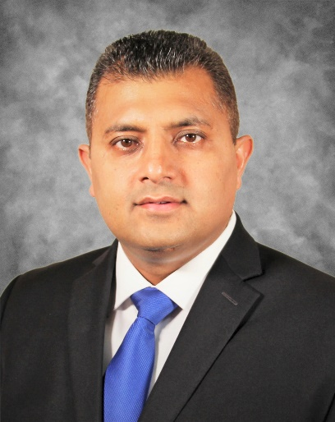
Speakers Bio:
Vijay Parashar, BDS, DDS, MDSc. is a Professor of Oral & Maxillofacial Radiology and Associate Dean for Academic Affairs at Midwestern University College of Dental Medicine in Arizona. He is a Diplomate of American Board of Oral & Maxillofacial Radiology. He received DDS from University of Detroit Mercy, MDSc and Certification in Oral & Maxillofacial Radiology from University of Connecticut. He received the Howard R. Raper Award from Indiana University School of Dentistry and William H. Rollins Award for Research from American Academy of Oral and Maxillofacial Radiology. He is currently serving as President of American Academy of Oral & Maxillofacial Radiology. He also serves on the National Dental Board Test Construction Committee and is American Dental Association Commission on Dental Accreditation (CODA) Site Visitor. He has interpreted over 10,000 CBCT scans.

