Prof. Emer. Shimon Friedman, D.M.D.

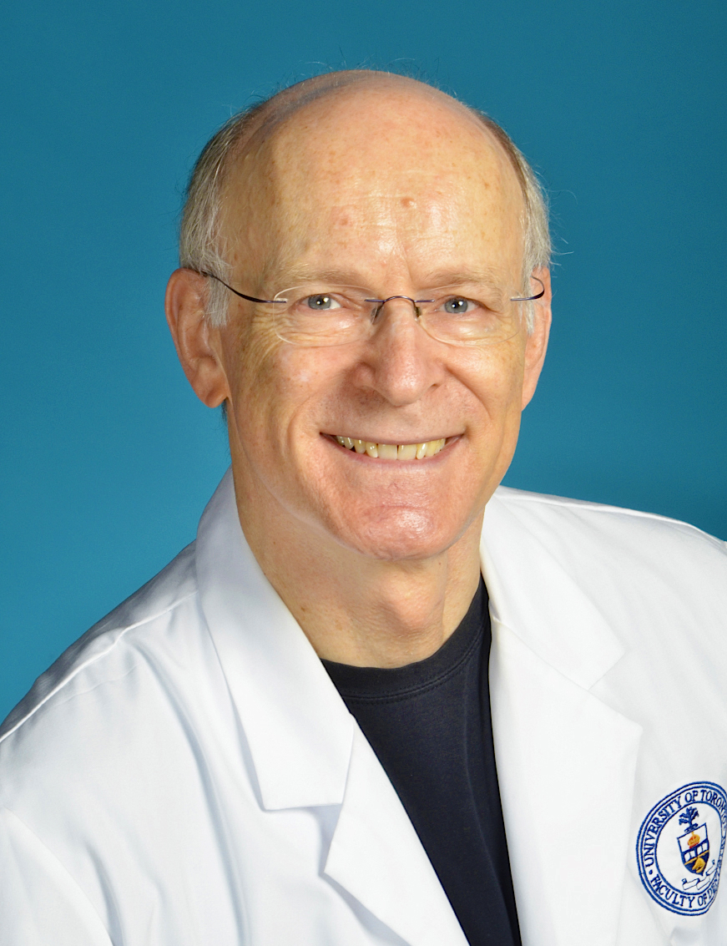

Dr. Shimon Friedman is Professor Emeritus at the Faculty of Dentistry, University of Toronto. He received the D.M.D. degree (1975) and endodontics certificate (1983) from the Hebrew University in Jerusalem, Israel. He is board-certified in endodontics in Israel and had served as Chairman of the Israel Endodontic Society from 1985 to 1988.

Prof. Friedman had served as Head of Endodontics in Toronto for 20 years (1992-2012), and as the founding Director of the MSc Program in Endodontics for 22 years (1993-2015). Under his leadership, the M.Sc. Endodontics Program at the University of Toronto has gained international recognition for its excellence.

Prof. Friedman has published over 250 peer-reviewed articles, textbook chapters and research abstracts, and has presented over 400 international lectures. He is ranked among the top 2% of cited researchers worldwide.

Prof. Friedman is the recipient of several awards, including 2006 Louis I. Grossman Award by the French Endodontic Society, 2008 Louis I. Grossman Award from the American Association of Endodontists (for “cumulative publication of significant research studies that have made an extraordinary contribution to endodontology”), 2013 W.W. Wood Award from the Association of Canadian Faculties of Dentistry (for “excellence in dental education”), 2014 Award of Distinction from the Faculty of Dentistry, University of Toronto, 2018 I.B. Bender Lifetime Educator Award from the American Association of Endodontists and Life Membership in the Omicron Kappa Upsilon Dental Fraternity, Tau Tau Chapter. In 2015, Prof. Friedman was designated an Honorary Diplomate of the Indian Board of Endodontics.

