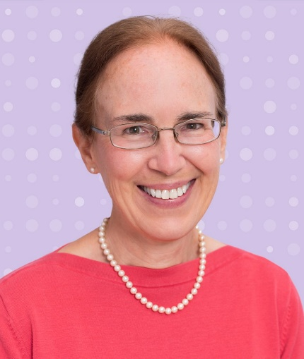
Dr. Lauren L. Patton (January, 2026)
Lauren L. Patton is a professor in the UNC at Chapel Hill Adams School of Dentistry Division of Craniofacial and Surgical Care. She is the Advanced Education Program Director for the General Practice Residency (GPR). Following graduation from UNC School of Dentistry and the 2-year UNC GPR, she completed the 2-year NIDCR Oral Medicine Fellowship in 1990. Her clinical interests are in the management of special needs and medically complex dental patients and diagnosing and managing oral manifestations of systemic disease.

She has served as principal investigator on industry, NIH, and CDC-funded research, published over 200 papers, monographs and book chapters, and lectured nationally and internationally on oral manifestations and management of patients with medical complexities, such as HIV/AIDS and oral cancer. She is a life member of American Academy of Oral Medicine (AAOM), Omnicron Kappa Upsilon (OKU) dental honor society, and the American Dental Association (ADA). An advocate for evidence-based dentistry, she served the ADA as a past member of the ADA Council on Scientific Affairs and remains a consultant/liaison for medical associations developing systematic reviews and practice guidelines at the intersection of medicine and dentistry. In 2013, she received the AAOM’s Samuel Charles Miller Award for Significant Contributions to the Science, Literature, and Patient Care in the Field of Oral Medicine.

She is a Diplomate and past president of the American Board of Oral Medicine and a Diplomate of the American Board of Special Care Dentistry. She is a past president of the AAOM (2019-2021), served from 2017-2025 as the Oral Medicine Section editor of the journal Oral Surgery, Oral Medicine, Oral Pathology, and Oral Radiology and received the AAOM Craig S. Miller Diamond Pin award in 2025. She is co-Editor of the John Wiley-published texts: ADA Practical Guide to Patients with Medical Conditions and Oral Medicine and Medically Complex Patients.

